- Create a counter using `useReducer` with actions: INCREMENT, DECREMENT, RESET.
Coding:
import { useReducer } from "react";

const initialState = 0;

function reducer(state, action) {
switch (action.type) {
case "INCREMENT":
return state + 1;

case "DECREMENT":
return state - 1;

case "RESET":
return 0;

default:
return state;
}
}

function Reducer() {
const [count, dispatch] = useReducer(reducer, initialState);

return (
<>
<h1>Counter: {count}</h1>

<button onClick={() => dispatch({ type: "INCREMENT" })}>
Increment
</button>

<button onClick={() => dispatch({ type: "DECREMENT" })}>
Decrement
</button>

<button onClick={() => dispatch({ type: "RESET" })}>
Reset
</button>
</>
);
}

export default Reducer;

Output:
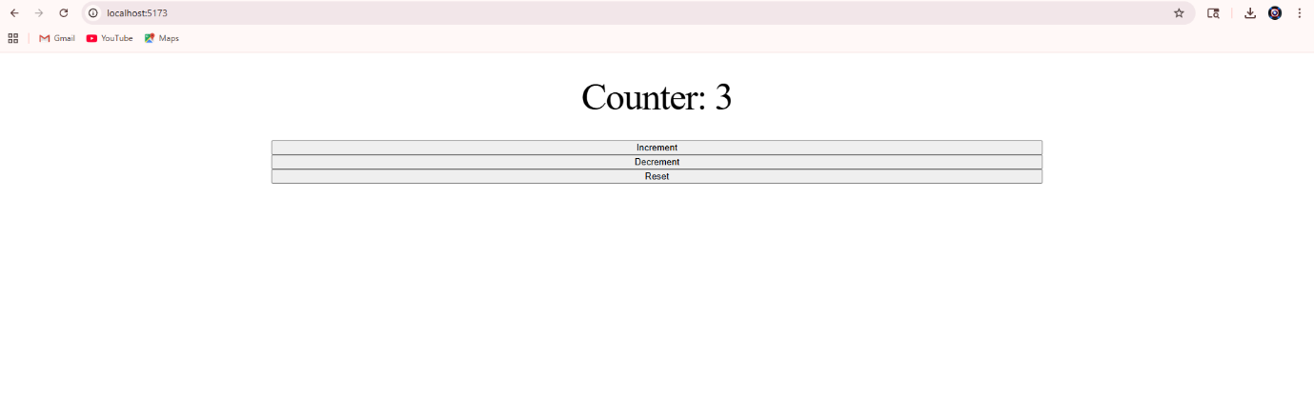

- Use `useRef` to focus the input when a 'Focus' button is clicked.
Coding:
import { useRef } from "react";

function FocusInput() {
const inputRef = useRef();

const handleFocus = () => {
inputRef.current.focus();
};

return (
<>
<input type="text" ref={inputRef} placeholder="Enter text" />

<button onClick={handleFocus}>
Focus
</button>
</>
);
}

export default FocusInput;

Output:
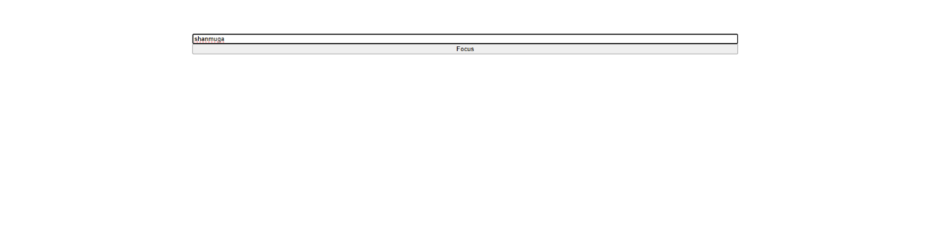

- Write a small utility to persist the counter in `localStorage` and rehydrate on load.
Coding:
import { useEffect, useState } from "react";

function PersistCounter() {
const [count, setCount] = useState(() => {
const saved = localStorage.getItem("count");
return saved ? JSON.parse(saved) : 0;
});

useEffect(() => {
localStorage.setItem("count", JSON.stringify(count));
}, [count]);

return (
<>
<h1>Counter: {count}</h1>

<button onClick={() => setCount(count + 1)}>
Increment
</button>
<button onClick={() => setCount(count - 1)}>
Decrement
</button>

<button onClick={() => setCount(0)}>
Reset
</button>
</>
);
}

export default PersistCounter;

Output:
